Project Design Phase-II
Data Flow Diagram & User Stories

Date | 27 June 2025
Team ID | LTVIP2025TMID31912
Project Name | Health AI: Intelligent Healthcare Assistant Using IBM Granite
Maximum Marks | 4 Marks

Data Flow Diagram

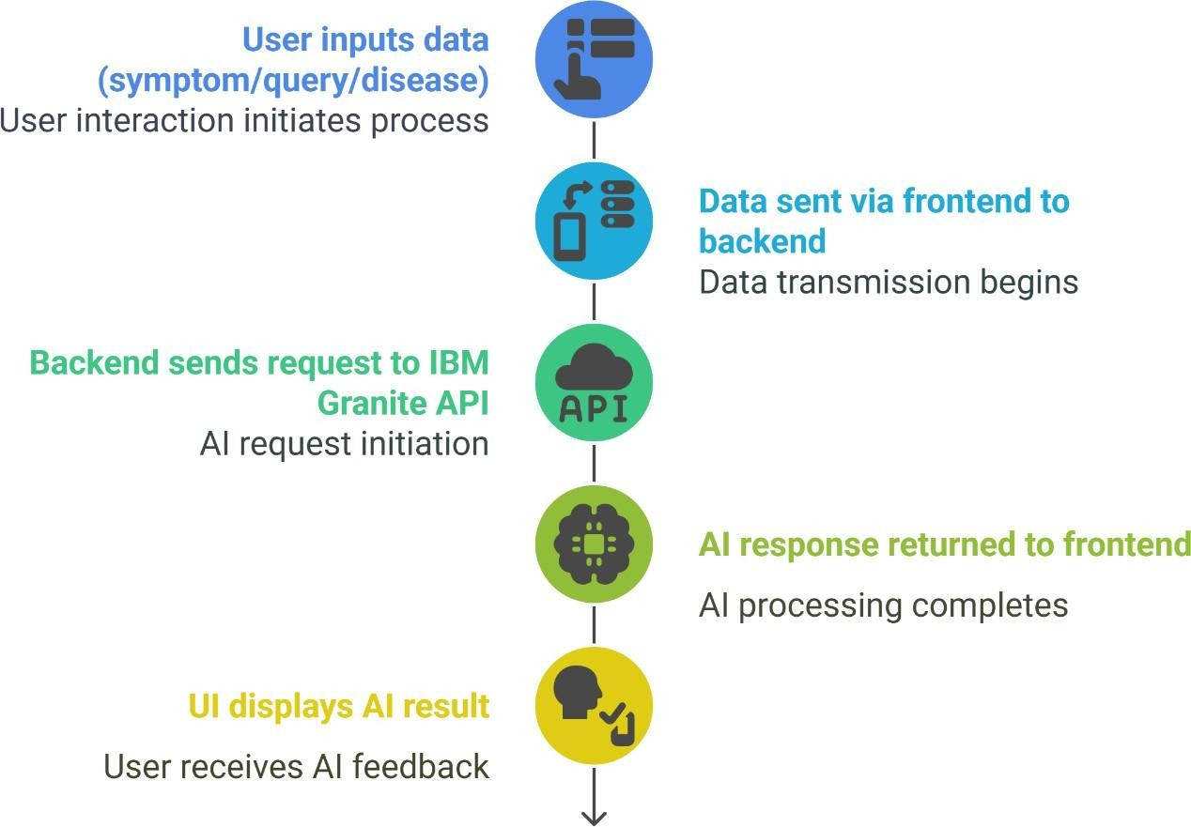

User Stories
1. Symptom Analysis
As a user, I want to enter my symptoms in my preferred language, so that I can get a possible diagnosis or condition suggestion in a language I understand.
Acceptance Criteria:
- The system accepts symptom input in any language.
- The system translates the input to English.
- The system returns a possible condition or diagnosis in a clear, understandable format.
2. Home Remedies
As a user, I want to enter the name of a disease in any language and receive natural remedy suggestions, so that I can try safe home treatments.
Acceptance Criteria:
- The system accepts disease input in any language.
- The system translates the input to English.
- The system returns a list of effective home remedies.
3. Medication Information
As a user, I want to know what medications are commonly used for a specific disease, so that I can understand my treatment options.
Acceptance Criteria:
- The system accepts disease input in any language.
- The system translates the input to English.
- The system returns a list of common medications (OTC or prescribed).
4. Disease Encyclopedia
As a user, I want to learn about a disease’s causes, symptoms, prevention, and treatment, so that I can be better informed about my health.
Acceptance Criteria:
- The system accepts disease input in any language.
- The system translates the input to English.
- The system returns a detailed explanation of the disease.
5. Patient Chat
As a user, I want to ask general health questions and receive clear, kind, and informative answers, so that I can get reliable health information.
Acceptance Criteria:
- The system accepts questions in any language.
- The system translates the input to English.
- The system returns a clear, empathetic, and informative response.

